Settings for your insulin (DIA and time-to-peak)
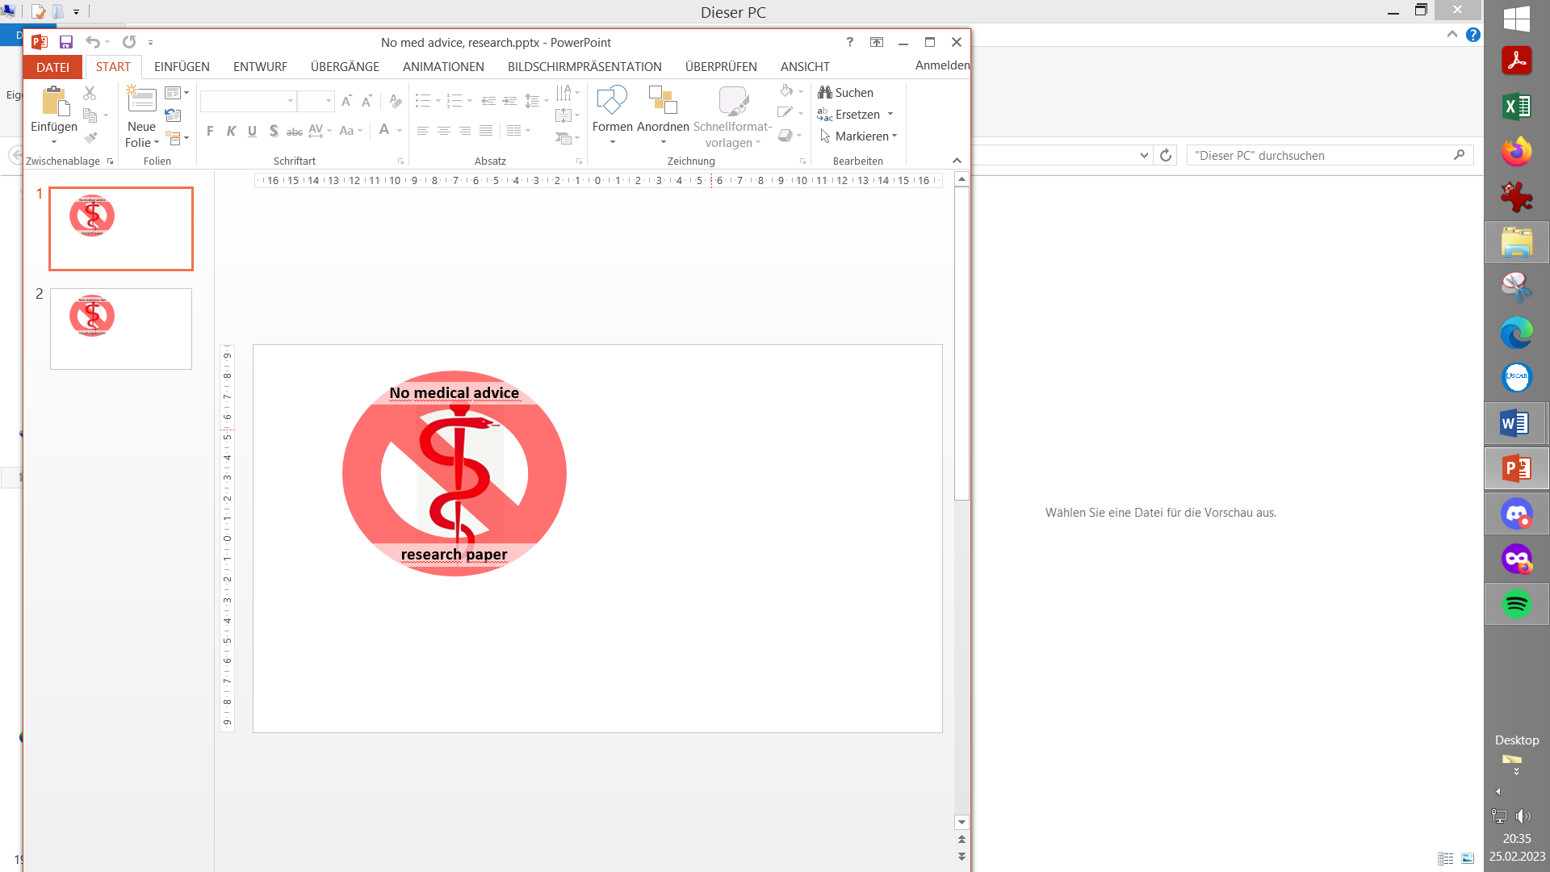
Contribution to the discussion among DIY loopers
The author assumes no liability V.3.3

- Setting insulin related parameters
1.1 Mathematical model used
1.2 Time-to-peak and DIA
- 1.2.1 Insulin choice matters for profile ISF, carb ratio
- 1.2.2 Duration of insulin action
- 1.2.3 Quantitative effects of changing DIA . 1.2.4 Shorter time-to-peak allows better control
2. Other factors of potential relevance
2.1 Age (of the diabetic)
2.2 Dose
2.3 Scatter (imprecision)
3. Mixes of two insulins
4. U200 insulin
5. Utilization of insulins with super fast bio-availability
5.1 i.v. insulin utilization
5.2 Inhaled insulin (Afrezza)
5.3 Glucagon micro-spiked insulin
5.4 Development of novel super fast insulins
5.5 Implantable insulin pump
5.6 Discussion

Before doing any other tuning, make sure you are on the insulin you really want to be on, and have reasonably set the insulin-related parameters for your looping system.

In case you are just starting to loop and need to “household” with your time, all you need from this paper should be just two messages:
- Select your insulin in AAPS configuration, and refer to the data given in section 1.2.2 regarding DIA. To set it on 9 h is a fair guess for a start, if you are uncertain.

- You probably heard that Lyumjev or Fiasp are in principle *) best for looping.
*) from an activity kinetics standpoint (see section 1.2.4)
In section 1.2.1 it is explained why it is a good idea to switch at the start of your looping journey, rather than at some later point.
Changes between insulins with similar time-to-peak, like Fiasp -> Lyumjev, will be easier, and will not require much of an adjustment as in the example given in section 1.2.1.
But of course you can switch at any later time, as well. Many prefer actually to start looping with a less reactive insulin. This enhances safety in the initial months of getting to know, and tuning, the loop. (Same thought is behind the Objectives in AAPS that give access to SMBs only after a couple of other steps).
Also, struggling with too many occlusions (and pain) can make it difficult to switch to one of the fastest insulins.

- Setting insulin related parameters
Besides time-(minutes) to-peak activity, also the duration of insulin action (DIA, hours) that you select in your profile strongly influences how the loop calculates the activity from insulin, as it unfolds in every 5-minute segment that your loop analyzes.
1.1 Mathematical model used
Especially what should be selected as duration of insulin action ( DIA ) is very strongly influenced by the model used to figure out active insulin two, three, and more hours after administration. Misunderstandings about this is often a source for disputes between loopers and their treating physicians.
All insulin administrations (bigger and minor) add up to a insulin activity pattern. In the case of looping, with user boli, basal insulin, TBR modifications and SMBs given at various times, with overlapping DIAs, this can be quite complex.
In AAPS you can see insulin activity in your main screen as an extra thin yellow curve. Together with carb absorption is “explains” most of what you see in your glucose curve.
This insulin activity pattern is an extremely important basis for each of your loop’s decisions. Having the wrong settings would give your semi-automated insulin management a permanent drift towards over- or towards under-corrections.
The loop system can still counter-regulate, but – if you burden your’s with wrong DIA or time-to-peak settings in your profile – this would “use up” some of it’s (limited) capacity to regulate for you.
Example: After heavy dinner, a DIA set too short “tells your loop” that active insulin is practically gone after time X. The loop takes that info for granted, and if it sees some insulin needed at that time X (and be it only for your profile basal need - as you also communicate to the loop, you need to remain stable -), then, at night-time, the loop will give you more insulin than you really need.
Therefore, before you tune your ISF differently, make sure to have a look at your DIA setting.
Please understand (and see to it, that your treating professionals understand) that models can differ strongly:
- DIY looping systems use the – less common – exponential decay model.
- Medtronic uses non-linear capped curves (as in handbook to their pumps)
- Doctors / diabetes educators mostly have a rough linear model in mind
- xDrip uses a bilinear math (“with kinks”) to model insulin activity (Caution: This info might be outdated)
All models are working „good enough“ for their (main) intended applications. But, as explained above, it is worth the effort to use an exact modelling of insulin activity for a loop, so it can perform optimally.
The mathematical model of insulin activity over time that we use anchors on time-to-peak (minutes) and on DIA (hours) in characteristic ways. This is quantitatively shown for exponential decay models in section 1.2.3-
In AAPS, the insulin tab shows two curves: The pink one starts at 1.0 (100%) and goes down to 0 (0%) when the DIA is over. It shows how much of the total activity (the capacity to lower bg) is left, at any time. So, it is like the iob number we always have in our AAPS home screen. The problem with that, as with the pink curve, is that it may give you a false impression regarding how much “power” there actually is, now, as you need it. That is where the other curve (and on your AAPS home screen, the related thin yellow insulin activity curve) come in: The blue one shows how the activity goes: Practically nothing (!) for a bunch of minutes, then rapidly going high, and then slowly fading out out over the DIA period (with a maximum at time-to-peak). For its calculations, AAPS adds these blue curves up for all boli, SMBs and TBRs $≠$ profile basal!

  - Time-to-peak activity and DIA for various insulins

Principally, there are „correct“ settings specific for each insulin type, notably regarding time-to-peak activity. This is pre-programmed in the insulin choices for AAPS, for instance.
Regarding the DIA to set, there is more uncertainty. The following mostly cites or summarizes finings published by David Burren.
1.2.1 Insulin choice matters for profile ISFs and carb ratios
The following chart is the inverse of the pink curve in the AAPS insulin tab: Not insulin still there to be used, but Insulin used up, going from 0% towards 100% in the 9 h DIA, for Humalog with 75 minutes, and for Lyumjev with 45 minutes time-to-peak.
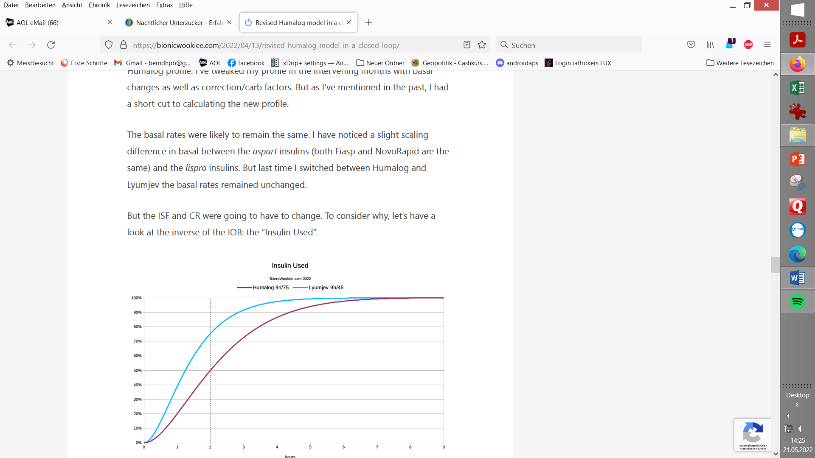
From a simplistic point of view, you can see that at the two-hour mark, more of the Lyumjev (75.5%) should have had effect than the Humalog (50.2%).
So when we’re calculating how much insulin to give for a correction, we should tell it to give more Humalog up-front to get the same result after 2 hours.
“With the current incarnation of the oref1 algorithm I do find it helpful to scale the ISF (and carb ratio) relative to the amount of each insulin used in the first 2 hours. For Fiasp ~66% is used in the first 2 hours. Lyumjev 75% (and NovoRapid/etc 50%).
Thus for Lyumjev I use ratios that are 15% larger than for Fiasp.
Basal rates are unchanged.” (D. Burren, AAPS Users 03Apr.2024)
The system will of course be tracking the IOB and forecasting the BG curves for hours into the future, so we do have some safety built in regarding the extra insulin.
When going from Humalog to using Lyumjev, this must have some consequences for the Insulin Sensitivity Factor (ISF) to use in the profile. If, for example, you had 1.8 mmol(l/U for Humalog, you should expect a “good ISF for going with Lyumjev” in the area of 2.7 mmol/l/U. According to the curves shown above (at dotted 2 hr line) a factor 75.5/50.2 applied yields the same amount of insulin for a correction.
Likewise, the Carb Ratio (IC or CIR) may deserve an adjustment when switching insulins.
- The carb ratio could be adjusted by the same factor, for instance it might go from 7.7 g/U (Humalog) to 11.6 g/U (Lyumjev).
For a meal of 60 g, 7.8 U (=60/7.7 g/U) Humalog would have contributed 3.9 U (=50.2%*7.8 U); likewise, 5.2 U (=60g/11.6 g/U) would have contributed 3.9 U (=75.5%*5.2 U)
- For meals bigger than about 60 g you should observe that, while your insulin bolus has good activity, only a limited number of carbs can get digested (30 g/h seems the limit for most). Refer to the paper on IC determination (section “Determination at meal times”) in: https://github.com/bernie4375/HCL-Meal-Mgt.-ISF-and-IC-settings/tree/FCL-w/autoISF
The given example showed that switching to a “faster” insulin can have relevant consequences for your key profile parameters.
David Burren also reports that between the two rather extreme insulin choices he tested, the total amounts of insulin (TDD) did not significantly differ ( - as we would expect: The same amounts just gets delivered slower, even at same selected DIA, with Humalog).
But while the TDD has not changed, the instantaneous insulin levels have.
When the system is fighting post-meal “highs” the IOB will be noticeably lower with Lyumjev.
Although the average overall level remains similar, this might have some implications for the concept of hyper-insulinaemia. This may be a subtle advantage of faster insulins.

1.2.2 Duration of insulin action

The following focusses on the more uncertain topic of which duration of insulin action (DIA) to use. It is largely relies on, and quotes, results from several thorough investigations done by David Burren: (https://bionicwookiee.com)
The numbers he ended up preferring are:
Insulin | Peak | Duration (DIA)
Humalog | 75 minutes  “Rapid-Acting Oref” | 7 hours *)=
NovoRapid | 75 minutes  “Rapid-Acting Oref” | 9 hours
Fiasp | 55 minutes  “Ultra-Rapid Oref” | 9 hours
*) Later investigations https://bionicwookiee.com/2022/04/13/revised-humalog-model-in-a-closed-loop/ led to suggesting 9 hours DIA also for Humalog
The default constraints in AAPS have the duration limited to 7 hours, so he had to make some local changes to the limits. It’s also possible if you set your “patient type” to “Pregnant”, but if so you need to carefully check all the affected safety limits (listed in the AAPS documentation). This may change in a future update to AndroidAPS.
For Lyumjev (45 minutes; Lyumjec Oref), there is not a big difference between a 7 and a 9 h DIA:
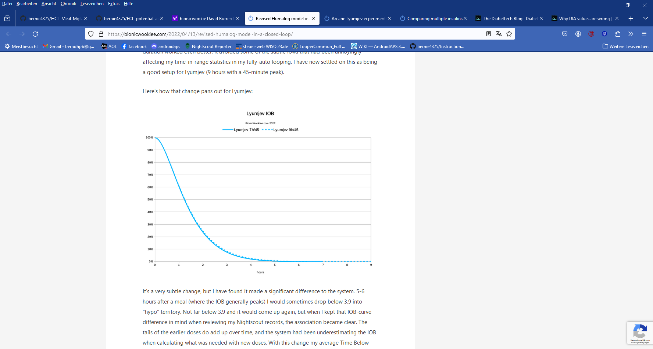
However, David Burren (https://bionicwookiee.com/2022/04/13/revised-humalog-model-in-a-closed-loop/ ) reports that, despite it’s a very subtle change, he has found it can make a significant difference 5-6 hours after a meal, when …the tails of the earlier doses do add up, and the system had been underestimating the IOB when calculating (using the shorter DIA) what was needed with new doses. With changing to a longer DIA, his average Time Below Range has reduced. (Comment: This is interesting for “fine-tuning extremists” but probably only a formal gain of little clinical significance, assuming the bg curve just swinging a bit more often, or longer, by a few mg/dl below the 70 mg/dl cut-off, that defines “below range”. Judge from your own data, when/if fine tuning.)
On the DIA topic for various insulins see also: https://www.diabettech.com/insulin/why-we-are-regularly-wrong-in-the-duration-of-insulin-action-dia-times-we-use-and-why-it-matters/

1.2.3 Quantitative effects of changing DIA

Any given insulin dose comes with a defined total capacity for a certain bg lowering effect. How strong or weak this unfolds over a couple of hours can be mathematically modelled. In oref(1) systems, time-to-peak and DIA completely define this curve.
We can look on effects of increasing the set DIA in terms of how insulin activity would differ at any moment after administering a dose.
The next example given (chart below) does that for going from a 5 h DIA, a 6 h DIA or a 7 h DIA towards 9 h for Lyumjev
We see the peak going lower, and the tail activity higher when DIA is increased:

LYUMJEV peak @45m max effect on “tail” at ~ 3.5 h (220 minutes)
DIA 5→9h | minus 5.5 % plus 2.5%
DIA 5→6h | minus 2,7 % plus 1.3%
DIA 6→9h | minus 2.8 % plus 1.2%
DIA 6→7h | minus 1,4 % plus 0.6%
DIA 7→9h| - minus 1.4 % plus 0.6%
So, the „tail“ effects differ by less than 3 percent (of peak activity=100%) in the later stages of DIA:
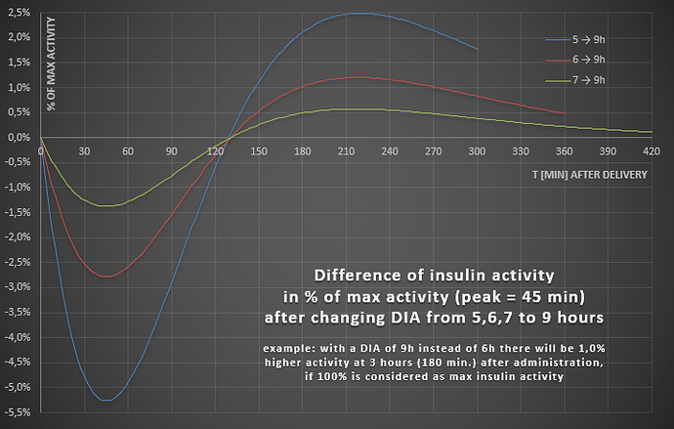
While 3 % sounds low, the significance of the problem should not be underestimated:
- For our Lyumjev case, note that the quoted 3% result is 3% of maximal activity.
Example: Activity at 180 minutes is about 0.0010 compared to 0.0080 at peak (blue curve in AAPS INS tab). 2.5% of 0.0080 would be 0.0002. BUT: 0.0012 is 20 % more than 0.0010, so REALLY the difference in activity at 180 minutes can be up to 20% . Still, after a bolus of 8 units (and/or SMBs that reach that iob level) for a typical meal, the max. difference from 5 -> 9 hour DIA would roughly be, whether 1.0 U or 1.2 U are active iob left at 180 minutes. That difference ( + 0.2 U) should be within the loop’s regulating capacity from reducing basal.
However,it becomes much bigger for users of other insulins (with longer time-to-peak):

- The delta effects get much bigger with insulins that have a longer time-to-peak
Some quantitative data for other insulins are as follows:
FIASP (peak=60m) min/max differences
DIA 5→9h | 6→9h | 7→9h: -10,1 / +6,8% | -5,6 / +3,0% | -2,9 / +1,4%

NOVORAPID (peak=75m) min/max differences
DIA 5→9h | 6→9h | 7→9h: -15,4 / +14,1% | -9,1 / +7,0% | -4,8 / +3,0%

Above example applied to Novorapid **): The effect would be up to +14.1% of max (!) => 2.1 U instead 1 U at 180 minutes. A difference of + 1.2 U results here, if DIA is set at 5, not at 9 h, so REALLY it could go up to + 120% !)
More see: szantos, de.loopercommunity.org May 2022 https://de.loopercommunity.org/t/naechtlicher-unterzucker/10626
**) 2,5% → + 0.2 U ergo 14.1% → +1,1 U stimmt insofern nicht ganz genau, als man beim Novorapid Case auch die Novorapid Peak-Höhe zugrunde legen müsste (die ich aber nicht greifbar habe). Wenn diese von Haus aus 20% niedriger nur kommt, hätten wir ca + 0,9U, also weiterhin etwa eine Verdoppelung … die wir mit unserer Wahl eines längerem DIA unserem Loop sagen könnten, damit er entsprechend weniger zu-schiesst … ergo weniger Hypogefahr hinten heraus …

1.2.4 Shorter time-to-peak allows better control of meal-related bg spikes
Note that this section 1.2.4 is about “the real” time-to-peak coming with your insulin choice; while the preceeding sections on DIA were focussing on effects if your set DIA is more or less “off” reality.
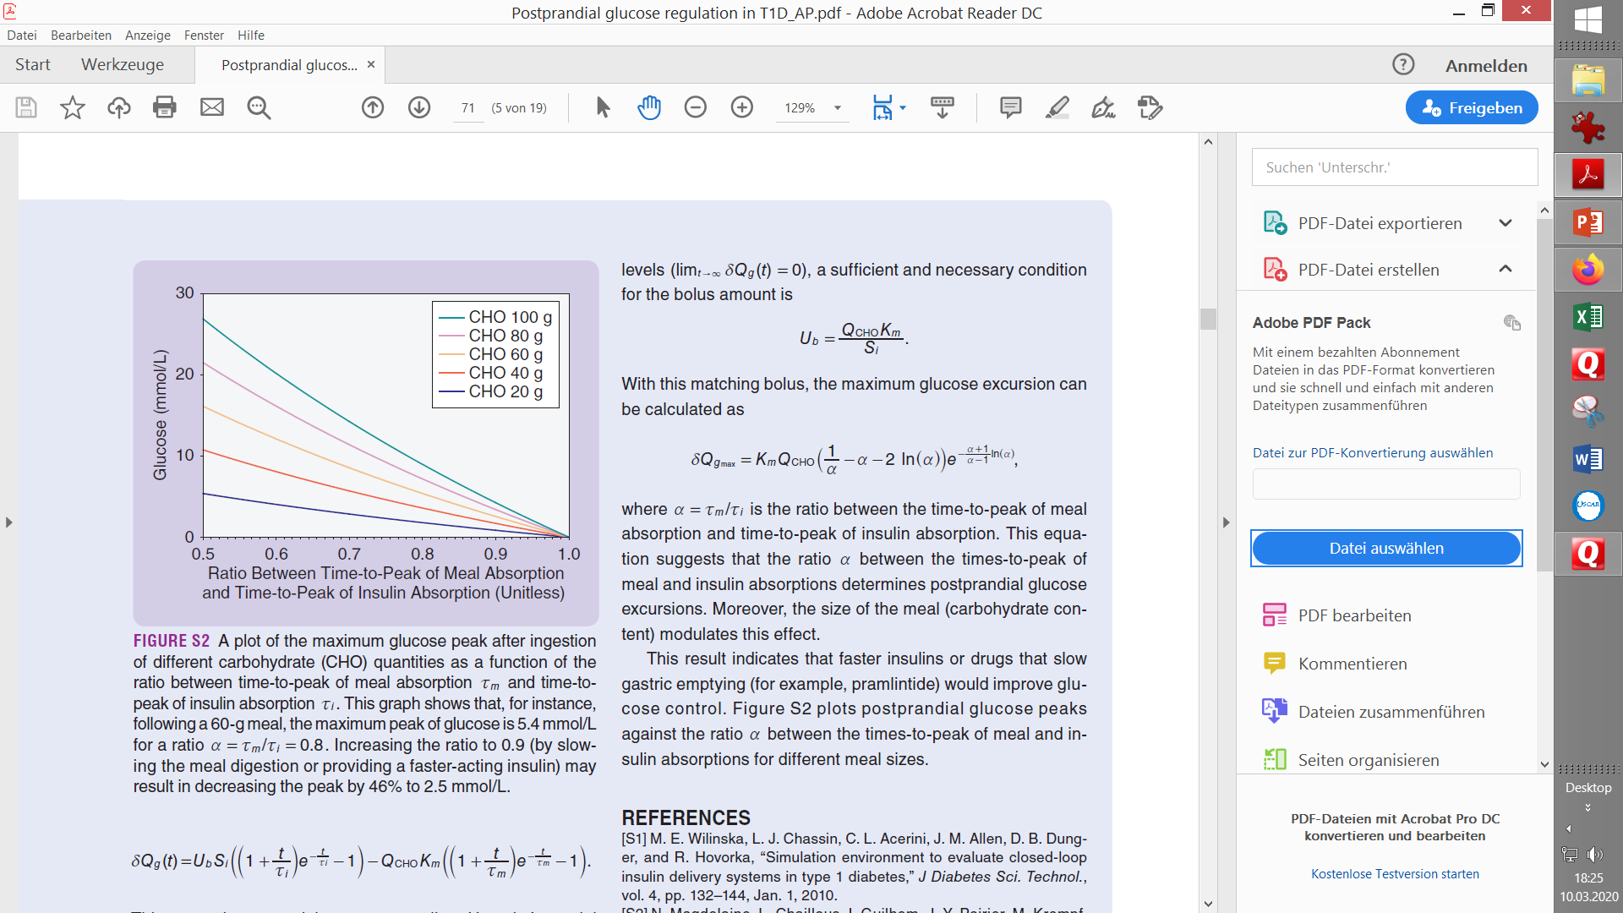
A modelling study „The Artificial Pancreas and Meal Control“ by A. El Fathi et al (https://github.com/bernie4375/HCL-Meal-Mgt.-ISF-and-IC-settings/blob/HCL-.-settings-main-repo-(pdf)/The%20Artificial%20Pancreas%20and%20Meal%20Control.pdf) can help us understand the effects on glucose peak heights from the course of carb absorption and of insulin activity. The graph shows on the y axis peak over baseline (the overall deltaBG in mmol/l), and on the x-axis the relative speed of insulin absorption to carb absorption. Carb absorption is always faster, therefore all values are under 1.0. But with Lyumjev we move closer to 1. The model calculation shows that faster
insulins (red dotted) will result in lower glucose peaks than slower insulins (violet dotted: reduction by 46% or minus 2.5 mmol/l = minus 46 mg/dl after a 60 g carb load).
So, this model supports that using a faster insulin will
- lead to less high glucose peaks, notably for bigger meals
- or might tolerate a couple of minutes delayed first meal bolus while not incurring unacceptable height of peaks.
The latter is a pre-requisite for full closed loop, in which we leave it up to the loop to notice that a meal „must have started“, and to come forward with SMBs that are typically delayed compared to the bolus as given in hybrid closed loop. This is an encouraging result.

Moreover, the same chart shows us that the spread between the colored curves (they stand for different meal sizes) becomes significantly smaller when we move to the faster insulin with a 0.9 ratio. This means the danger of increasingly high post-meal glucose peaks for high-carb meals is sharply reduced, too. For example, the green curve suggests with the „0.8 insuline“ a peak of 10mmol/l (180 mg/dl) above your glucose level at meal start, but only +4 mmol/l (+70 mg/dl) when using a faster insulin with factor 0.9, which, when starting at or under 110 mg/dl, could keep glucose in range.
The message we can take from this is:: The higher carb loaded our diet, the more important to use the fastest-available insulin.

See chapter 5. regarding what is being developed to speed-up time to peak activity further.

- Other factors of potential relevance Source: szantos
The findings reported below can give you hints in which direction to look if you attempt to fine-tune your settings further, from the standard suggestion what should be suitable for your insulin (section 1.2.2.).
2.1 Age (of the diabetic)
ema.europa.eu

novorapid-h-c-258-p46-0044-epar-assessment-report_en.pdf 3
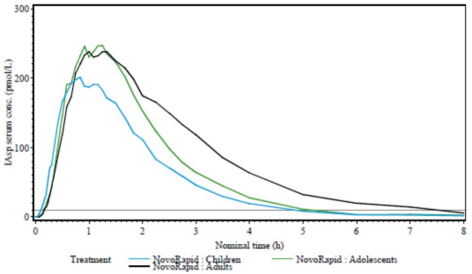

  - Dose
https://journals.sagepub.com/doi/10.1177/1932296813514319
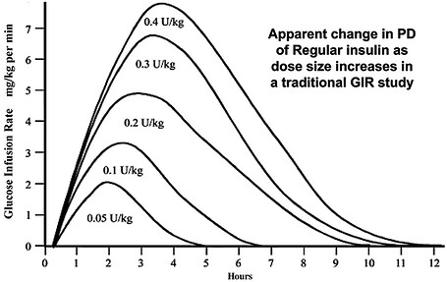
image1000×632 78.4 KB

  - Scatter (imprecision)

Individual deviations from standard suggestions could also be justified by the fact, that all studies that underly the previously reported suggestions, come with very significant person-to-person scatter.
All lines in the charts, as above shown from studies, are averaged data. (Some studies are indicating the very significant scatter seen, as well).
https://www.researchgate.net/figure/Pharmacodynamic-profiles-Insulin-action-as-expressed-as-GIR-required-to-maintain_fig1_41424712 2

- Mixes of two insulins

The author did for some time successfully use a 50/50 mix of Fiasp and Novorapid, applying the time-to-peak for Fiasp, and longest of the two DIA, as was suggested at the time, for these insulins.

For a more thorough discussion see https://bionicwookiee.com/2022/03/02/mixing-insulins-theory-and-practice/
and also: https://bionicwookiee.com/2023/06/03/arcane-lyumjev-experiments/

- U200 insulins

Using up-concentrated insulins, e.g. in a U200 form, is sometimes chosen by loopers
- to reduce needed daily insulin volumes and get more time from 1 pump filling (pod)
- to reduce volume per injection for getting better tolerance regarding occlusions or pain
There are no relevant effects on insulin parameters like DIA and time-to-peak.
However, dilution or up-concentration factors are highly relevant for setting profile factors like ISF and IC, and also for some important safety settings like max iob for instance.

Refer to special discussions on that topic, e.g. here re. U200 Lyumjev https://www.diabettech.com/lyumjev/living-with-lyumjev-almost-a-year-in-review/ :
and also: https://bionicwookiee.com/2023/06/03/arcane-lyumjev-experiments/

- Complementary utilization of insulins with super fast bio-availability
The effect of time to peak activity on bg control was shown quantitatively in the study presented in section 2.1.4. It is the core problem coming with any sub-cutaneous insulin provision (via sub-cutaneous injections, or via insulin pumps), that time-to-peak activity can be rather long.
In this section 5. we touch on faster ways to get insulin into blood. With a possible exception of 5.2 on Afrezza: Please note that the author does not encourage you to try any of those unless in a medically supervised study context. Also, be aware that faster acting insulins further increase danger of hypoglycemia.
5.1 Using i.v. insulin
The “beauty” of using intra-venous insulin at around meal starts would stem from its much faster bio-availability, and also much shorter DIA
Case report: “I do a basically unknown amount of insulin intravenously, let it be between 4 and 8 units (well below the size that my meal bolus would be). It really doesn’t matter anyhow. What it does ,it brings me down to target within 30-40min. I record something like 4-6 units (so my loop doesn't want to get excessive insulin). Essentially, this prevents getting insulin longer than it actually has an effect (mine is gone from the system after 35min). To eliminate the false “activity tail” assigned also to the i.v. portion of insulin on bord, you can delete the i.v. insulin amount from the system after it has done it's job (not good for statistics/history data, but right, going forward without the DIA tail = letting your loop know the real iob).
It's an edge use (experimental) case “ (source: Robert, discord FCL/iaAPS w autoISF, March 2024):
Please observe that this is not a recommendation to experiment with i.v. insulin unless in a medically supervised research context.
i.v. insulin is usually restriced to the surgical and intensive care hospital environments!

  - Inhaled insulin (Afrezza)
Afrezza is an inhalable very fast (and also short) acting insulin which some find useful to correct high glucose levels.
Pro: An insulin inhalation can prevent, or quickly correct, a high bg. Due to its short DIA, a late hypo tendency from-a long “tail of effects” can be avoided, as well.
Cons: 1) Afrezza spray is hard to dose, and spraying into the lungs may not tolerated well. High cost. 2) It is not advisable to enter data into loop because the kinetics of this insulin are very different. => The short term problem is solved, but there will be consequences from skewed calculations if your looping mode relies on data like TDD, cob, Autosens, Autotune.
Conclusion
- “Afrezza is fast enough to take effect and also to get out (super short DIA) that it doesn't necessarily impact the rest of the model: The spikes you'd normally expect don't tend to happen” (Tim Street).
You could look at it as, via Afrezza, “faking” “low carb meals always” to your loop: Your Afrezza shot takes quick care of the fast carbs (which you better not declare). All AAPS has to do, is take care of the effects from slow carbs and FPUs that need insulin when Afrezza effects are over.
(More discussion on Afrezza in AAPS looping see Craig Gordon 14Sep.2024 in Facebook AAPS users· ernoSodstp6S40i 5heba14rf5m3hiip g i:1tm e708M6f7la0f2cl2Ptehi4 ).
- Primary approach should be to go without Afrezza, and avoid high bg by finding a proper meal management strategy (pre-bolus time, EatingSoonTT).
- If you have access to Afrezza, try it occasionally within your conventional meal management (2) to see how it might help you manage rapid carbs.
Solving the problem at hand as best as we can, even if it makes the time afterwards a bit more complicated, is the name of the game. We and our loop do this all the time, for instance by giving more upfront insulin, then reducing basal (zero-temping).(quoted from Afrezza chapter in: Meal Mgt. 3..pdf, https://github.com/bernie4375/HCL-Meal-Mgt.-ISF-and-IC-settings )

Caution: Your looping algorithm is built on having realistic iob data, and carb (or carb deviation) data. With Afrezza, you strongly interfere. It is your responsibility as early tester to think things through, so you can avoid risks. For example:
- You probably must reduce the maxIOB set in AAPS Preferences by your usual (not-declared) Afrezza dose
- Timing of Afrezza application will make a huge difference in post-prandial bg curve characteristics. Applying as early as possible is super crucial if you operate with aggressive SMB settings (notably in autoISF FCL, where you probably must significantly lower the iobTH, too).
- But applying Afrezza very early comes with immediate hypo risks. Be aware that, the faster acting the insulin, the more difficult it will be to counter-act with glucose tablets!

  - Glucagon-micro-spiked insulin
A highly experimental approach to further improve the kinetics of Lyumjev for looping has been researched by a T1D physician (Dr. Carlsen, Trondheim, Norway) in self-experiments, with some promising first results. 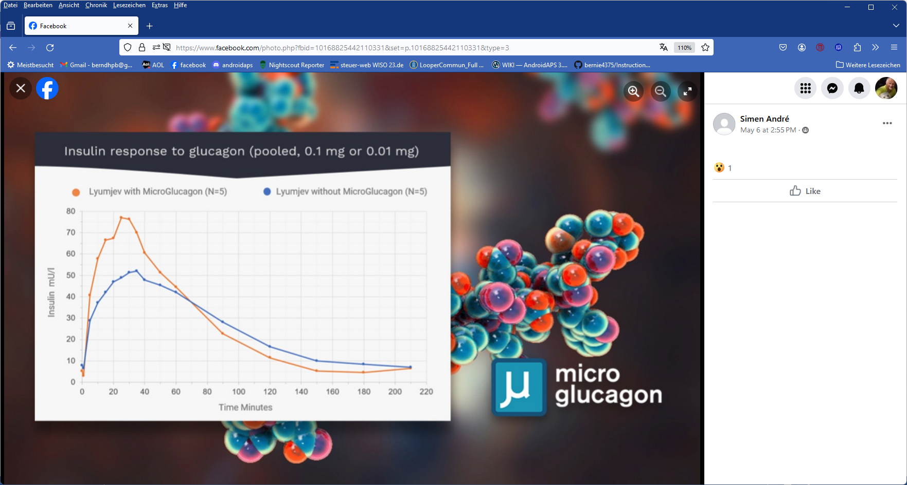
Full article from Norwegian hospital researchers group: https://norwegianscitechnews.com/2024/01/a-new-insulin-mixture-could-make-life-easier-for-patients-with-type-1-diabetes/
Our DIY researches pushed the topic further – see https://discord.gg/eHSgx5jWuk -
and the red curve may resemble their current status (graphs are scaled to show the relative strengths or patterns):
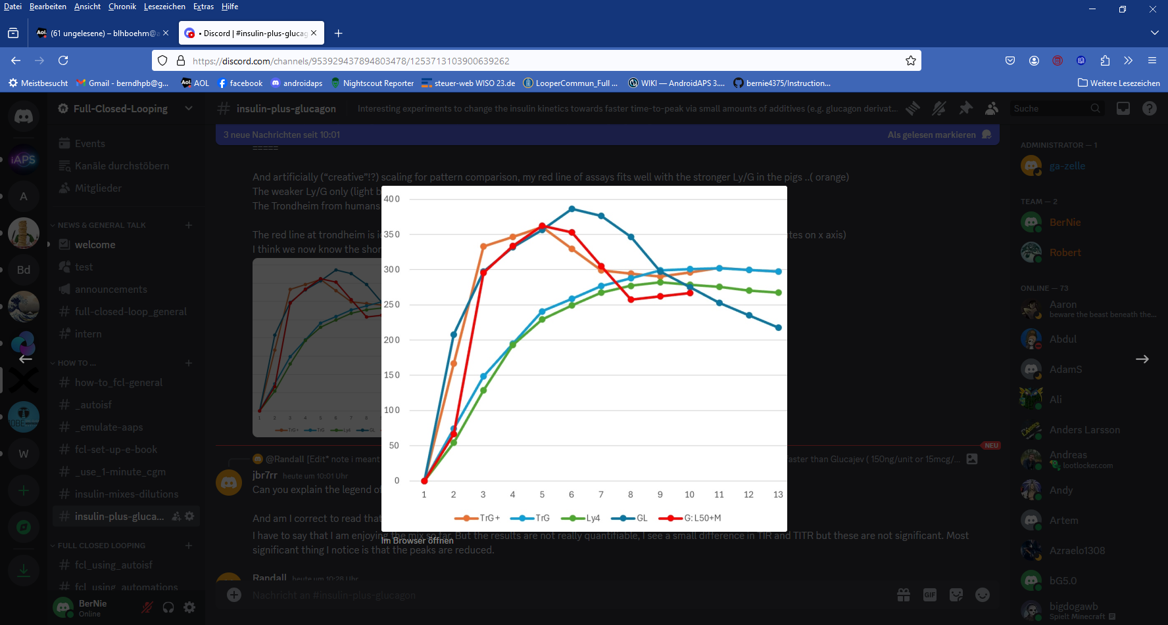
TrG+: Trondheim stronger G mix, tested on pigs TrG: Trondheim weaker (?) G mix ( equivalent to just lyumjev elsewhere.. their lyumjev control was way worse!) Ly4: the 4th lyumjev article I had.. best approximation I think GL: Trondheim original graph (dark blue here; was orange on previous page) which was the human one I think GL50+M (red): modified GL graph of my own DIY mix*) and blood tests for sequential insulin assays.
*) high dasiglucagon (200ng/unit) similar Trondheim high G , but other additives as described in Discord
Note: Scales x, y are done so that “our” red curve approximates the orange TrG+ as found by Trondheim researchers (with pigs, in their case)

Caution: Changing medications can be dangerous, and is not advised outside of a supervised medical study.
Also, your looping algorithm is built on having realistic iob data. By mixing-in glucagon, you strongly interfere. It is your responsibility as early tester to think things through, so you can avoid risks.

For example, you should give AAPS ( under Config.Builder/Insulin/Free Peak Oref ).a suitable insulin kinetic model (and make sure your mix is stable, regarding that, during the period of use). More see in Discord: https://discord.gg/eHSgx5jWuk , notably @ jbr7rr ( 21.01.25, 14:14 ) and some entries by David Burren.

See more related discussion:

in Discord: https://discord.gg/eHSgx5jWuk

in “AAPS Users” FB (Alf Einar Johnsen, Jan 19, 2024) https://www.facebook.com/groups/AndroidAPSUsers/permalink/3733005573587499/?mibextid=W9rl1R

or in “iAPS unchained” FB (Robban Jansson, 06 May, 2024) https://www.facebook.com/groups/151989761311250/permalink/286074914569400/

Development of novel super-fast insulins

According to https://arecor.com/wp-content/uploads/2022/01/220120-Arecor-Formulation-Expertise-Exemplified-in-Diabetes.pdf there is already a super fast insulin for sub-cutaneous pump delivery in clinical trial stage, AT247 (by Atera). It showed a 17 minutes onset of glucose-lowering action (compare: 37min.Novorapid, 23 min.Fiasp, data not given for Lyumjev, ca 20 min.). Unfortunately, it still has a long DIA and therefore it will not be the ultimate thing (… and might turn out inferior to glucagon addition to Lyumjev as discussed in section 5.3)

So, that one could be a gradual improvement over Lyumjev.

Getting insulin activity from (micro)boluses something like 5 minutes earlier would further limit bg rises (see section 1.2.4 ). However, it could not contribute much to resolving a major problem we still see today in Full Closed Loop, which is: Fighting the rising bg is principally limited because the inevitable “tail” of insulin activity produces hypo danger.

Implantable insulin pumps

Implantable insulin pumps already do exist since about 15 years (e.g. Medtronic-MiniMed). These remain at all times in the peritoneal cavity, which has a rich supply of blood vessels and can therefore absorb insulin very efficiently.

“Bypassing subcutaneous insulin delivery with continuous intraperitoneal insulin infusion has been shown to be an effective treatment option.^{1–4} The benefits of this treatment emanate from more reproducible and preferential portal absorption and hepatic extraction of insulin, thereby leading to improved mimicking of the physiological situation compared with continuous subcutaneous insulin infusion” (cited from: https://www.thelancet.com/journals/landia/article/PIIS2213-8587(14)70035-X/abstract ).
Intraperitoneal insulin infusion has been associated with a more rapid onset of action and reduced duration of activity compared with subcutaneous insulin.
Both these effects are clearly what we are after for making Full Closed Loop more effective
- Rapid onset -> see chapter 1.2.4
- Shorter DIA -> eases “fighting high bg peaks” by reducing associated dangers of later going into hypoglycemia from prolonged insulin activity (“tail effects” and ensuing roller-coastering often discussed in t1D meal management context).
“These findings have led to the development of implantable insulin pumps, that is, disk-shaped infusion systems that are implanted surgically in the abdominal subcutaneous tissue. The pump reservoir holds a 2- to 3-month supply of insulin and is connected to a free-moving peritoneal catheter. Rates of insulin delivery are adjusted by the patient, based on CGM results. The patient uses an external programmer that sends radio wave signals to the electronic command unit of the pump to control the rate of insulin infusion.
Studies to date suggest that implantable insulin pumps are associated with comparable A_{1c} levels and a reduced incidence of severe hypoglycemia **) compared with subcutaneous insulin delivery.
The main problem with implantable pumps is the potential for underdelivery of insulin due to catheter occlusion,” (Cited from: https://www.sciencedirect.com/topics/nursing-and-health-professions/implantable-insulin-pump. **)see: Liebl, A ∙ Hoogma, R ∙ Renard, E ∙ et al. A reduction in severe hypoglycaemia in type 1 diabetes in a randomized crossover study of continuous intraperitoneal compared with subcutaneous insulin infusion. Diabetes Obes Metab. 2009; 11:1001-1008)
As also implantable CGM system do already exist (Eversense), the technical hurdle to develop an implantable closed loop prototype seems actually quite low.
Probably, as some of us have experienced already regarding Eversense, the hurdle is more about inflexibility in case of problems. We all are used to working around problems by having spare sensors or pump components resp. pods with us. However, access to getting a new implant will often not be easy. Besides being a big inconvenience, it will also be a significant cost factor.

Discussion

Above we have explored routes for a potential real break-through, providing faster onset of insulin activity PLUS also a very much shortened tail of action.

An insulin that acts even faster than any carb absorption will, by design, be geared to reacting on development of the bg curve. This brings huge advantages:

No need for carb counting, and forbidden (!) to give meal (pre-)boli.

Therefore such insulin should be restricted for pump use only.

Rapid onset, PLUS short “tail” of activity, allows to operate near-physiologic data regarding both, very small very frequent insulin doses, and bg not peaking super high, ever. .

Technically this concept should be better than the dual hormone route (section 13.6 of FCL e-book: https://github.com/bernie4375/FCL-potential-autoISF-research-/blob/FCL-book-autoISF) because it needs no additional reservoir and pump. Also, one reactive, fast regulation should principally be better than a sluggish regulation, with counter-regulation in form of a quick correction by small titered dose of glucagon, on top.

However, the dual hormone system might be safer in real life – see first point under …problems (below).

But it also comes with a couple of problems:

It requires to educate people that using that insulin in a syringe (or also manually issuing a bolus from their pump) is an absolute no-go. However, today everybody is used to doing just that, and we all know too well the temptations to occasionally give a correction bolus.

It will be interesting to see how manufacturers would cover themselves from lawsuits because normal people in some everyday situation, or in a special situation, may do it in a way that now, with that innovative insulin, is definitely wrong. Note that once that new insulin is “in”, no glucose tablet can rescue you any longer. You probably would need glucagon syringe immediately. (As already hinted on above, this is where the competing dual hormone approach to FCL can play out an important advantage: It has that glucagon safeguard “right on bord”!)

It absolutely requires a 24/7 reliable CGM (because the rapid corrections shoot towards a target value that might be dangerously skewed)

Again, from everyday observations we know that only a minority even of today’s loopers do have reliable CGM values every day. If a broader group of T1Ds is targeted, this can turn out a real barrier. .

It also requires nearly 24/7 Bluetooth connectivity (because system will fall back to profile basal, or to no insulin at all, when it cannot loop, and high bg would result, coming with the temptation to issue a manual bolus….)

A pretty much hands-off (no bolus, no carb inputs) Full Closed Loop system could be designed with a high degree of system integration and miniaturization (pod+CGM+algo); this could provide rock-solid connectivity.

From a commercial standpoint this must make us wonder whether it would be commercially rolled out at all, and for which target group.

It would be nice if it were launched to transform current (and future) commercial loops into FCL mode. Due to liability concerns, especially in the US, very strong safety measures would need to be built-in, like not allowing to set “low” target bg (limitations we already know from current commercial systems). Commercially seen, this might open a big enough market, to offer the majority out there on high HbA1c a rather care-free option to get into the ~ 7% range. If cost-effectiveness (and safety) can be shown (and it might), this could revolutionize T1D treatment, with Full Closed Loop on a pump+CGM becoming the standard. (The author is not familiar enough with type 2 diabetes management to say anything whether, after some foolproof system integration (pod+CGM+algo), it could extend into that very broad market, as well).

Especially if safety issues remain, alternatively routes to achieve around 80% TIR for a broad T1D audience have already been described in a clinical study based on AAPS: https://pubmed.ncbi.nlm.nih.gov/36826996/

Current FCL users on autoISF who like to see HbA1c around or even under 6% are a “too small group” to be of any interest; but they could benefit from a super fast insulin (fast on-set PLUS fast fading-out!) immediately, after giving their system the applicable kinetic curve for that insulin (in AAPS easy possible under Config.Builder/Insulin/Free Peak Oref). This would improve fighting post-prandial peak heights without ensuing hypo danger (which, currently with Lyumjev, is a delicate balancing act in initial system tuning).

